

**BRAC Bank**

**SME Dashboard**

User Manual for Mobile App

Document Version 1.0  
09 January 2022

**Disclaimer**

This guide has been validated and reviewed for accuracy. The instructions and descriptions it contents are accurate for BRAC Bank SME Dashboard, Mobile App. However, succeeding versions and guides are subject to change without notice.

**Revision History**

|  |  |  |  |
| --- | --- | --- | --- |
| **Revision No.** | **Created/Updated By** | **Release Date** | **Comments** |
| 1.0 | A S M Lutful Kabir | 09 January 2022 | 1st Release |

Table of Contents

1 About this Guide 6

2 Purpose of this Guide 6

3 Typographical Conventions 7

4 Application Channel 7

5 Application Login Page 8

6 Territory Manager Module 9

6.1.1 General Dashboard (Summary) 9

6.1.2 Accounts 10

6.1.3 BDM Reports 11

6.1.3.1 Existing SME Lists (Deposit) 13

6.1.3.2 Existing SME Lists (Customer Projection) 13

6.1.4 Upload SME Account 14

6.1.5 Export Upload History (Loan) 15

6.1.5.1 Export Upload History (Deposit) 16

6.1.5.2 Export Upload History (Customer Projection) 16

6.1.5.3 Export Upload History (Employee Info’s) 17

6.1.6 File Upload History 18

6.1.7 Estimated Payment History 19

**6.2** SME Product 20

6.2.1 Add New Products 21

6.2.2 Existing SME Products 22

6.3 User Management 23

6.3.1 Add New User 24

6.3.2 Upload Excel File 25

6.4 Product Campaign 26

6.4.1 Add New Campaign 27

6.5 Role Management 28

6.5.1 Add New Role 29

7 Business Development Manager (BDM) Module 30

7.1.1 Summary 30

7.1.2 Accounts 32

7.1.3 RO Reports 33

7.1.4 Help 34

7.2 SME Products 35

7.3 Product Campaign 36

8 Relationship Officer (RO) Module 37

**No table of figures entries found.**

**List of Figures**

Figure 1 Log in Page 8

Figure 2 Admin Dashboard 9

Figure 3 Existing SME Lists (Loan) 10

Figure 4 Existing SME Lists (Deposit 11

Figure 5 Existing SME Lists (Customer Projection 11

Figure 6 Upload SME Account 12

Figure 7 Export Upload History (Loan) 13

Figure 8 Export Upload History (Deposit) 14

Figure 9 Customer Projection 14

Figure 10 Export Upload History (Employee Info's) 15

Figure 11 Estimated Payment History 16

Figure 12 Estimated Payment History 17

Figure 13 SME Product 18

Figure 14 Add New Product form 19

Figure 15 Add New Products 19

Figure 16 Existing SME Products 20

Figure 17 Existing SME Products (Deposit) 20

Figure 18 User Management System User List 21

Figure 19 Add New User Form 22

Figure 20 Database Relational Table 23

# About this Guide

This document will deliberately guide you to use every possible option/feature of BRAC Bank SME Dashboard, Mobile App in details.

# Purpose of this Guide

This document describes functional and application level features of BRAC Bank SME Dashboard Mobile App. However, through this guide user will get conversant with application’s usage/working procedures.

The users/stakeholders of this Mobile app should get a rigid overview on the application through this guide.

*User*: The primary users for this module would be Admins of the system and other allotted members/users who would be categorized in the system as:

# Typographical Conventions

|  |  |
| --- | --- |
| **Type Face** | **Meaning** |
| **Bold** | Used to indicate buttons on the screen. |
| *Italic* | Used as special instructions/actions/notes and reference to other sections. |

# Application Channel

The application will be used by intended users on their Android supported Smartphones.

# Application Login Page

* The Login page will provide a glimpse of the entire solution.
* 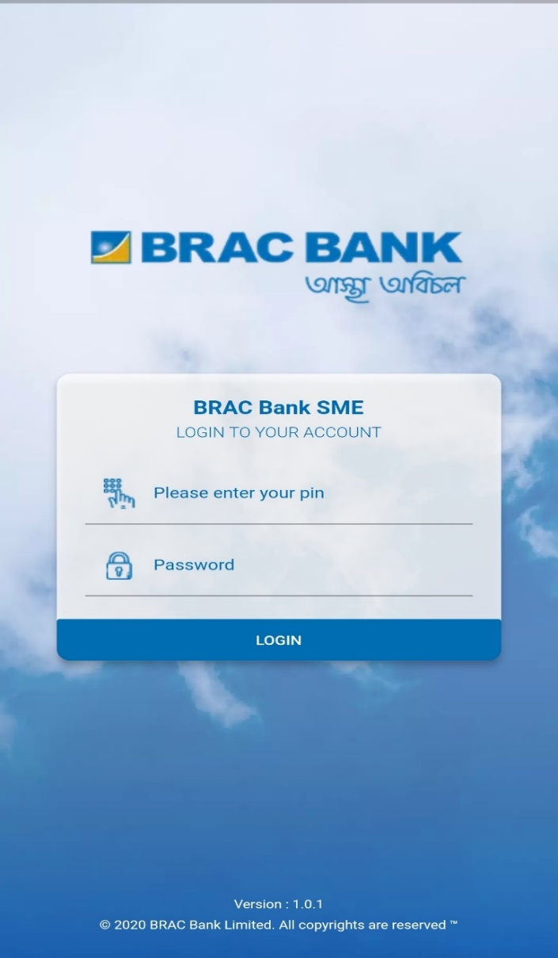 Users of defined roles (TM / BDM / RO) will be able to login using their unique pin and password.

Figure 1 Log in Page

3

2

1

1. Enter relevant PIN for Relevant user (TM / BDM / RO)
2. Enter relevant Password.
3. Click on Login button to log in to the system.
4. On the first time Login into the system user will redirect to **Password reset form**;

# Territory Manager Module

* Using relevant credential for Territory Manager, user will log into the system;

**5**

**4**

1

### General Dashboard (Summary)

Figure 2 General Dashboard (Summary)

* Clicking on General Dashboard user will find following sub-menu

1.Summary 2. Accounts 3.BDM Reports 4. Help;

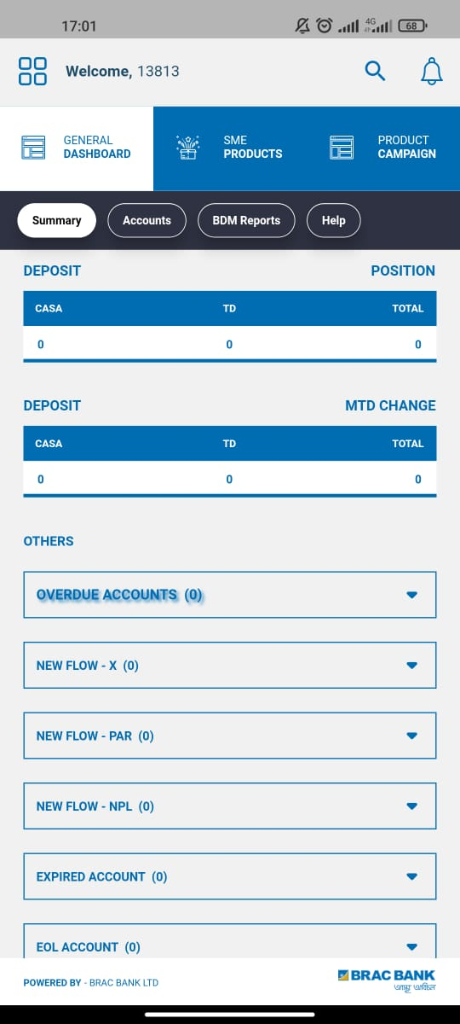

Figure 3 Summary (2)

* Scrolling down user will find following dropdown options:
* Expired Account; EOL Account;

### Accounts

Figure 4 Accounts

* Clicking on Accounts user will redirect to this sub-menu.
* Here user will find Following information tables.
  + Loan; Deposits; Monthly Projection;

### BDM Reports

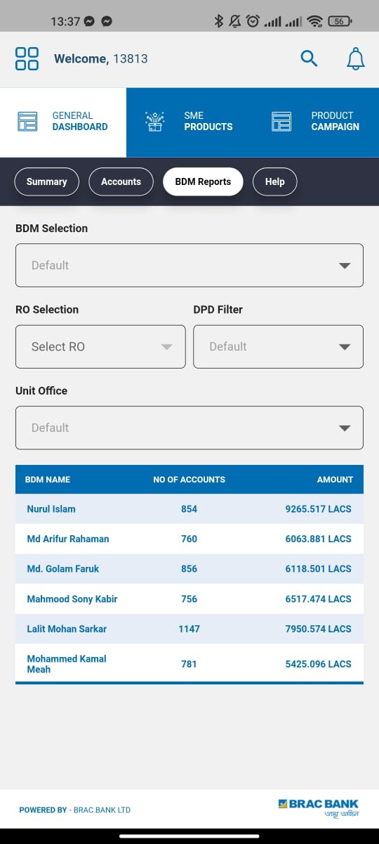

Figure 5 BDM Reports

* Clicking on the BDM Reports sub menu button user will redirect to relevant page.
* Here user will find few Dropdown button (BDM Selection, RO Selection, DPD Filter, Unit Office)
* Using the drop-down buttons user can view desired information;

### Help

Figure 6 Help Sub menu

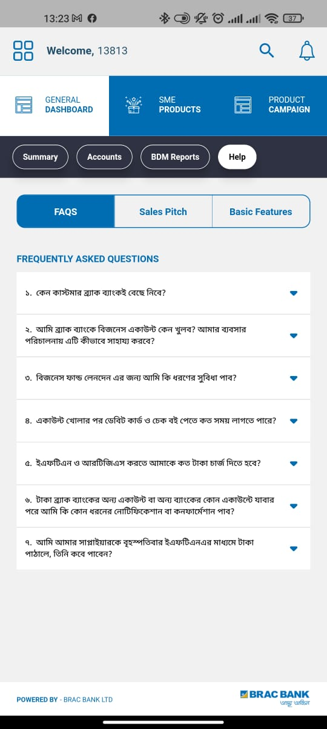

* Clicking on the Help Sub menu user will redirect to Help page.
* Here user will find following tabs FAQ, Sales Pitch, Basic Features.

## SME Products

Figure 7 SME Dashboard (TM)

* Clicking on SME Products menu user will redirect to relevant page;
* Click to access Loan Products and Deposit Products;

## Product Campaign

Figure 8 Product Campaign

* Clicking on Product Campaign User will redirect to relevant page;
* Here user will find all the relevant campaign here;

# Business Development Manager (BDM) Module

### Summary

Figure 9 Dashboard (1)

1

2

* After logging in into the system, User will redirect to General Dashboard
* Here user will find following sub-menu:
  + Summary; Accounts; RO Reports; Help
* Here user will find following sections: Asset, Deposit, Overdue Accounts

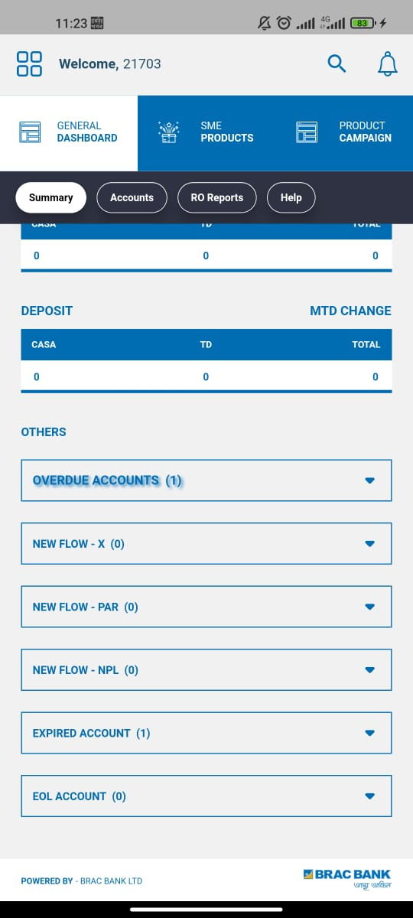Figure 10 Dashboard (2)

* Scrolling down user will find following dropdown options:
* Expired Account; EOL Account;

### Accounts

Figure 11 Accounts

* Clicking on Accounts user will redirect to this sub-menu.
* Here user will find Following information tables.
  + Loan; Deposits; Monthly Projection;

### RO Reports

Figure 12 RO Reports sub Menu

* Clicking on the RO Reports sub-menu user will redirect to relevant page.
* Here user will find following dropdown: RO Selection; DPD Filter; Unit Office;
* Using the drop-down buttons user can view desired information;

### Help

Figure 13 Help sub-menu

* Clicking on the Help Sub menu user will redirect to Help page.
* Here user will find following tabs FAQ, Sales Pitch, Basic Features.

## SME Products

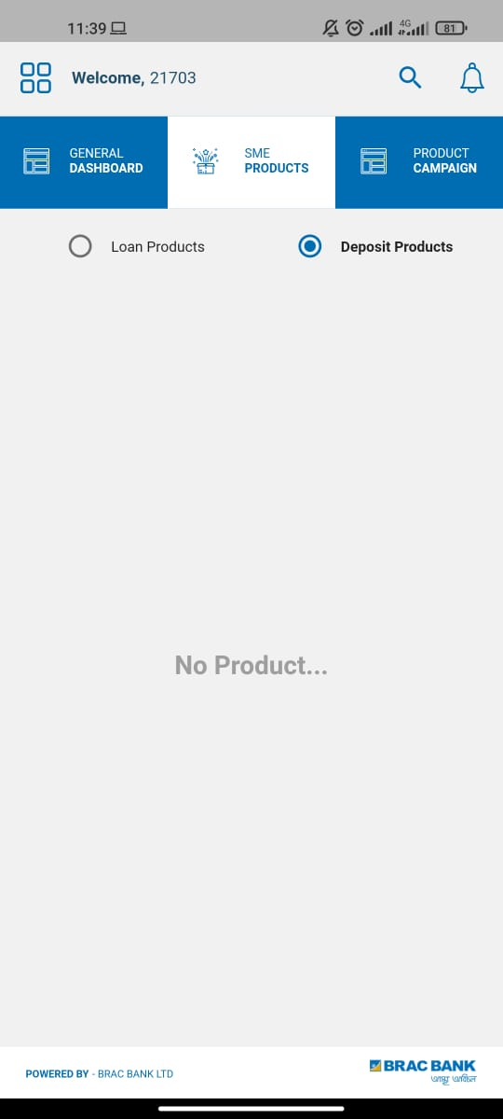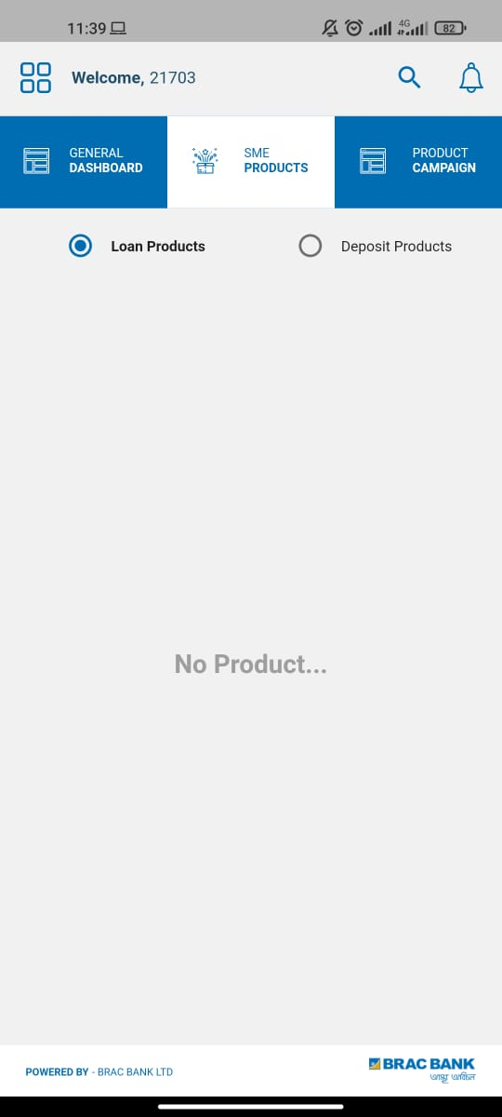

Figure 15 SME Products (Deposit)

Figure 14 SME Products (Loan)

* Clicking on SME Products menu user will redirect to relevant page
* Click to access Loan Products and Deposit Products

## Product Campaign

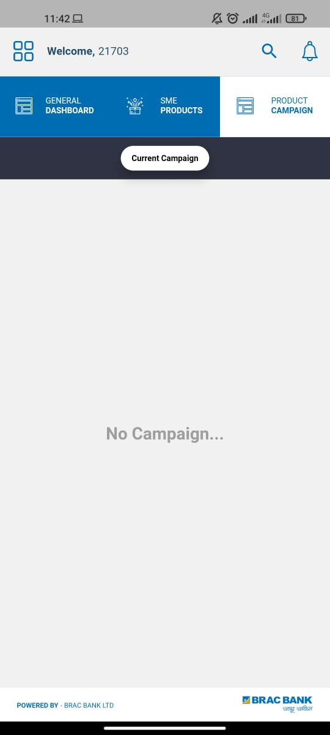

Figure 16 Product Campaign

* Clicking on Product campaign menu user will redirect to relevant page;
* Here user will find all the product campaign;

# Relationship Officer (RO) Module

### Summary

Figure 17 Summary (RO)

* After logging in into the system, User will redirect to General Dashboard
* Here user will find following sub-menu:
  + Summary; Accounts; RO Reports; Help
* Here user will find following sections: Asset, Deposit, Overdue Accounts

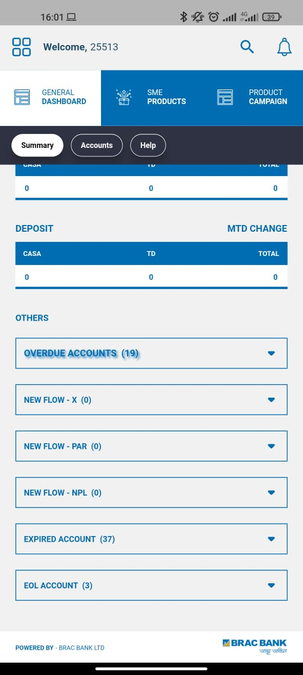

Figure 18 Dashboard (2)

* Scrolling down user will find following dropdown options:
* Expired Account; EOL Account;

### Accounts

Figure 19 Accounts

* Clicking on Accounts user will redirect to this sub-menu.
* Here user will find Following information tables.
  + Loan; Deposits; Monthly Projection;

### Help

Figure 20 Help

* Clicking on the Help Sub menu user will redirect to Help page.
* Here user will find following tabs FAQ, Sales Pitch, Basic Features.

## SME Products

Figure 21 SME Products (RO)

* Clicking on SME Products menu user will redirect to relevant page
* Click to access Loan Products and Deposit Products

## Products Campaign

Figure 22 Products Campaign

* Clicking on Product campaign menu user will redirect to relevant page;
* Here user will find all the product campaign;

# Notification Module

Figure 23 Notification Module

2

1

1. Click to access Home page
2. Click to access In app Notification

## Homepage

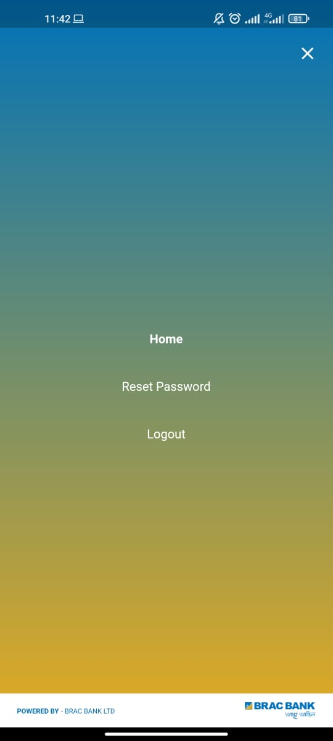

Click to Log out

Figure 24 Homepage

* After clicking on the button user will redirect to homepage;
* Here user will find Reset Password button;
* Clicking on the Log out button user will log out of the system

## In App Notification

Figure 25 Notification

* Clicking on the Bell button user will find all the In-App Notification for the relevant user;

Thank You

For Using

SME Dashboard Mobile App